**EMPOWER GRASS-ROOT CSOS FOR IMPROVED INNOVATIVE ENVIRONMENTAL PROTECTION IN ALBANIA**

**ENVIRONMENTAL ACTIVISTS AND CSOs NEEDS ASSESMENT REPORT**

**APRIL 2021**

**Table of Contents**

**INTRODUCTION** 2

**1.** **METHODOLOGICAL APPROACH** 2

***1.1.*** ***Target groups*** 2

***1.2.*** ***Final beneficiaries*** 3

**1.3.** **Data Collection and Analysis** 3

**1.4.** **Gender Mainstreaming Strategy** 3

**1.5.** **Risk Management - Strengths and Limitations** 4

**1.5.1.** ***Advantages*** 4

***1.5.2.*** ***Disadvantages*** 4

***1.5.3.*** ***Risks*** 4

**1.6.** **Monitoring Procedures** 4

**1.7.** **Recommendations for sub granting processes** 5

**1.8.** **Appendixes** 5

**2.** **PROFILES AND RESULTS FOR NORTH-WEST REGION** 5

**2.1.** **Lezhe and Shkodra Region** 5

**2.2.** **RESULTS** 7

**3.** **PROFILES AND RESULTS FOR NORTH-EAST REGION** 13

**4.1.** **Kukës Region** 13

**4.2.** **Dibra Region** 15

**4.3.** **RESULTS** 16

**5.** **PROFILES AND RESULTS FROM SOUTHERN REGION** 19

**5.1.** **Gjirokaster Area** 20

**5.2.** **Berat Area** 20

**5.3.** **Vlore Area** 21

**5.4.** **Korce Area** 21

**5.5.** **RESULTS** 21

**6.** **PROFILES AND RESULTS FOR CENTRAL REGION** 29

**6.1.** **Tirana region** 30

**6.2.** **Durrës Region** 30

**6.3.** **Elbasan region** 31

**6.4.** **Fier region** 31

**6.5.** **RESULTS** 33

**7.** **SYNTHETIZED CONCLUSIONS** 37

**8.** **RECOMANDATIONS** 37

**ANNEX 1: QUESTIONNAIRE FOR ENVIRONMENTAL CIVIL SOCIETY ORGANIZATIONS** 38

**ANNEX 2: ENVIRONMENTAL ACTIVISTS, EDUCATION INSTITUTIONS, ACADEMIA, LOCAL PRIVATE BUSINESSES** 46

**Table of figures**

**Figure 1. Preference of CSOs in the North-West region on environmental trainings** 9

**Figure 2. Factors that influence women's participation in environmental activities, North-West Region** 9

**Figure 3. Main environmental issues according to activists in the North-West Region** 10

**Figure 4. Sectors in which women in the North-West region are directly engaged in the management of natural resources** 12

**Figure 5. Expressed interest of CSOs per type of grant in the North-West Region** 12

**Figure 6. Number of members of CSOs in the North-East Region** 17

**Figure 7. Women's position in CSOs in the Southern Region** 23

**Figure 8. Environmental concerns mostly addressed by CSOs in the Southern Region** 24

**Figure 9. Level of collaboration between CSOs in the Southern Region and other actors** 24

**Figure 10. Collaboration of CSOs with Women Empowerment organizations in the Southern Region** 25

**Figure 11. Main financial resources of CSOs in the Southern Region** 25

**Figure 12. Gender composition of the associations in the Southern Region** 27

**Figure 13. Main environmental issues addressed by activists in the Southern Region** 27

**Figure 14. Level of participation of activists on environmental topics in the Southern Region** 28

**Figure 15. Number of members of CSOs in the Central Region** 33

**Figure 16. Environmental concerns mostly addressed from CSOs in the Central Region** 33

**Figure 17. Perception of CSOs regarding factors affecting women's participation in environmental activities in the Central Region** 34

**Figure 18. Level of cooperation between CSOs and Women's Empowerment organizations in the Central Region** 34

**Figure 19. Expressed interest of CSOs per type of grant in the Central Region** 36

# INTRODUCTION

The purpose of this report is to assess the capacity, operations and scope of activists and CSOs at National and sub-national levels, focused on environmental and gender-equality issues. Specifically, it aims on contributing to the improvement and factorization of environmental activists and CSOs to effectively address environmental challenges in Albania for tangible change. This report will assess the socio-economic, politico-cultural, legal environment and context within which activists and CSOs operate; the human, material, financial and technical capacities of activists and CSOs operating at the regional and national levels. The findings will help Green-Al partner and staff members to support empower grass-root CSOs and activists toward achieving enhancement of their capacity, innovation and evidence-informed input and advocacy role in environmental policy-making processes.

Through this needs assessment process we intend to contribute on the improvement and factorization of environmental CSOs to effectively address environmental challenges in Albania for tangible change. The projects aim:

1. *To enhance the capacity of Albanian local environmental CSOs, through a comprehensive, and capacity building strategy implementation.*
2. *To introduce innovative models in environmental management and capacity development through a comprehensive and integrated sub-grant scheme addressing environmental topics at local level.*
3. *To factor the CSOs' evidence-informed input and advocacy role in environmental policy-making processes.*

Strengthening of small local CSOs networks and the creation of new opportunities of collaboration among CSOs, public authorities, and the private sector at local level, so to build a vibrant, empowered and collaborative civil society starting from the bottom to impact then the national level through a multi-stakeholder’s response.

Contribution to the improvement and factorization of environmental CSOs to effectively address environmental challenges in Albania for tangible change. The project will focus on the strengthening of small local CSOs networks and the creation of new opportunities of collaboration among CSOs, public authorities, and the private sector at local level, so to build a vibrant, empowered and collaborative civil society starting from the bottom to impact then the national level.

1. **METHODOLOGICAL APPROACH**

To stimulate collaboration at local level, a new concept of multi­stakeholders' response to the most pressing environmental needs will be introduced and put in practice. This will enable us to find the right mix between local initiatives tailored to the specificities of each given context and a tangible impact at national level in terms of replicability of good practices, advocacy and general public environmental responsibility.

* 1. ***Target groups***

1. *Environmental CSOs including grassroots organization and citizens' fora which are committed in environmental sector, youth organizations and young activists;*
2. *Education institutions and academia;*
3. *Private Sector;*
4. *Local public authorities;*
   1. ***Final beneficiaries***
5. *The Central Institutions engaged in policy-making better positioned to make evidence- informed decisions, policy formulations, or policy improvements.*
6. *Population of the focus areas, affected by the environmental challenges, yet supported through the project activities including those of sub-grantee organizations, to more effectively engage in environmental protection and advocacy.*
7. *General public expected to benefit from increased environmental protection awareness, and improved addressing of environmental challenges.*
   1. **Data Collection and Analysis**

The methods that will be used with the purpose of data collection are as follows:

1. *Survey through the dissemination of the Questionnaires attached in the Appendixes of this document using online tools and channels;*
2. *Focus Groups with the different stakeholders;*
3. *Interviews;*
4. *Document reviews;*
5. *Focus groups*
   1. **Gender Mainstreaming Strategy**

The project will follow a tailored Gender Mainstreaming Strategy that is established due to the initial acknowledgement of potential gaps and obstacles of this kind that will be faced during the inception and implementation phase, and therefore for the purpose of mitigating them.

The framework of this strategy is founded upon the principle of the promotion of gender equality and is operationalized through tools such as the Questionnaires and the Grant Schemes’ Guidelines. More concretely, gender mainstreaming will be implemented when assessing the needs of the targeted beneficiaries, so as to have the intended comprehensive data that enables an inclusive analysis and therefore design of Sub-Granting Schemes.

Furthermore, the components of this strategy will be fine-tuned based on the NA results, further developing the set of mechanisms and incentives that will be integrated in the Guidelines for the Grant Schemes, in order to promote gender equality and gender responsive models among the grassroot CSO-s, activists and also in the local communities through their projects.

* 1. **Risk Management - Strengths and Limitations**
     1. ***Advantages***
  2. *Allows for face-to-face contact and observing behavior.*
  3. *Allows exploring and clarifying opinions, or dealing with the unexpected.*
  4. *Helps engage participants in the TNA process.*
  5. *Helps explore / confirm other data / information (for example, the information obtained from documents).*
     1. ***Disadvantages***

1. *Can be time consuming and depend on the availability of individuals.*
2. *Individuals can’t always identify or express true needs.*
3. *Some may use this opportunity to vent frustrations or discuss other issues.*
4. *Interviewers must be skilled and well prepared.*
5. *Interviewing many can be time consuming and expensive.*
6. *Requires careful sampling when dealing with a large interview population.*
7. *Interviewers sometimes ‘take over’ and negatively affect the* 
   * 1. ***Risks***
8. *Political instability in the country, meaning that the current priority agenda and the institutional set up operate normally, and is not challenged by unforeseen developments that could overturn the order of priorities.*
9. *Low absorption rate of technical skills, know-how and opportunities among CSO’s and Media.*
10. *Governments do not recognize the potentials of evidence-based debates as structured input for sustainable reforms to ensure public involvement in policy making and M&E.*
11. *Lack of Media interest to cooperation with the project.*
12. *Proposals submitted are not a good reflection of current issues locally.*
13. *Local CSOs have limited experience and access to advocacy actions/ decision-making powers.*

* 1. **Monitoring Procedures**

1. **Continuous support** (*thematic or administrative) to sub-grantee organizations during the process of project implementation to ensure implementation issues are identified and dealt with in a timely manner.*
2. **Systematic reporting** *(narrative and financial): Annual reporting practice will apply, including both narrative and financial. On a sub-grantee level, reporting frequency will be higher to ensure healthy project management practices and timely monitoring and feedback.*
3. **Frequent Online Communication** *(conference calls, electronic communication): In addition to in-person meetings, frequent calls among all project partners will be scheduled to take place systematically, as an opportunity to discuss on project implementation issues and dynamics, monitor performance and decision-making.*
4. **Internal assessments**: *in order to assess the performance of the capacity building project activities in a manner that is timely and actionable, a survey will be done.*
   1. **Recommendations for sub granting processes**

This section describes the implications from the data and suggests next steps for environmental issues. (*to be better defined once the final questions of the questionnaires have been received*)

* 1. **Appendixes**

Included with the report should be the data collection instruments used, such as the questionnaires and focus group questions, and the schedule of activities that contributed to the process.

1. **PROFILES AND RESULTS FOR NORTH-WEST REGION**
   1. **Lezhe and Shkodra Region**

The Region of Shkoder is rich in natural attractions and offers a wide biodiversity of flora, fauna and natural habitats, especially in the protected areas of the Shkodra Lake, the Theth National Park, and the protected landscape of Buna-Velipoja. Here, during the last two decades, the uncontrolled human intervention led to the loss of biodiversity, in the most severe cases, also to the extinction of some species.

In the Shkodra Lake only, it is possible to find more than 10 different habitats, whose systems vary over time depending on the development of biotic factors and on the season changes of the water level, and where about 850 plant species and 600 animal species exist. Seven specific spots of the Shkodra Lake are listed among the endangered habits, for example Syri i Sheganit in Malësi e Madhe, the coastal forests in Shegan Kamicë, Shkodra Vraka, Zogaj, Tarabosh and Shiroka.

The Buna river hosts a biodiversity with a high natural value, richer in the past than nowadays. This river, along with its tributaries, represents one of the most important corridors in Europe for the migration of specific species of fishes and of birds - in fact, here some bird watching towers have been built in recent years. One of the main degrading factors has been the illegal logging up to the point of complete deforestation.

Theth National Park is known for its rich diversity of species, fauna and flora. About 1500 species of plants are found and live in this area, which represent almost half of the flora of our country. In the list of plants that live in this area about 100 species are medicinal herbs, very useful for human health, while about 70 species are at risk of extinction. The admirable location constitutes the right habitat for different species of wildlife, such as bears, wild goats, wild boars, deers, wolves, linxes, lizards and hedgehogs, not to forget birds like eagle, hawk, quail, and many other that migrate to Theth in the breeding season. Many of these species are endangered, as well.

The flora and the fauna are threatened by the misuse and the poor management of these resources with a great environmental, economic, and social value. The increase in the population has also put pressure on the natural habitats of the area, exploited for economic profits. An additional factor is the persistent low level of environmental education and of environmental awareness. Nowaday, the issues that are more evident in the Shkodra region are: loss of habitats and degradation of the ecosystems in the Shkodra Lake, the Buna River, and the Viluni Lagoon, worsened by frequent floods and erosions; by sewages; by the urbanization and increase of urban waste in the coastal areas.

The Region of Lezha includes the municipalities of Lezha, Mirdita and Kurbin. Lezha is one of the most important centers of the northwestern territory of Albania in several respects, where mountain, plain, forest, archeological and historical monuments, lagoon and sea form a prominent community. The territory is intertwined and is part of this area, where all the conditions for the development of fauna and flora are quite diverse, for the preservation of which the whole community must take care and contribute. In this territory, a variety of ecosystems coexist, such as marine, coastal, rivers, evergreen and deciduous Mediterranean shrubs, deciduous and mixed coniferous forests, meadows and pastures.

Based on the high values ​​of biodiversity that they represent within the territory of the Region of Lezha, there are two protected areas, which according to the IUCN classification are part of Category IV - Managed Nature Reserves / Nature Park: Kune - Vain, Bërzanë, Lura National Park, Ulza Lake Regional Natural Park, Berzana Nature Reserve, and Kthelle Regional Natural Park. The main area where the effects of climate change have begun to be felt lies in the Drin and Mat River Delta (DLDM) and has been identified as a vulnerable region critical to climate variability and its expected effects. The increase of human pressure has led to significant changes in the environment of the DLDM area. Across the DLDM area, rapid population growth is modifying the natural environment through the overuse of coastal, marine and estuarine resources with irreversible consequences such as: Loss of coastal, marine and estuarine habitats; Disappearance of important geomorphological features (sand dunes); Significant loss of coastal vegetation, flora and fauna; Disappearance of buffer zone; Change in the distribution of alien (invasive) species; Reducing the regenerative capacity of ecosystems by rising sea levels and climate change; Penetration of salt water. The resulting degradation has a number of consequences that limit both existing and future opportunities for human use of the area, such as: Erosion and sinking of low-lying areas by rising sea levels and rising storm frequencies, leading to loss of space; Change of hydrological regime, leading to loss of freshwater for agriculture, other industries and for domestic use; Loss of wetland area, leading to reduced opportunity for protection from rising sea levels, loss of attractive values ​​of ecosystems and their services; Habitat and biodiversity change leading to loss of resources and environmental renewal.

Both regions inherit important natural resources, but it should also be noted that inadequate waste management, misuse of agricultural land, chaotic urban development, high land erosion, overuse of groundwater, degradation of natural protected areas and impoverishment of biodiversity, are among the main environmental problems facing this area. These environmental problems are also associated with the low quality of human resources, which is a characteristic that is generally encountered in all small towns.

The project will follow a tailored Gender Mainstreaming Strategy that is established due to the initial acknowledgement of potential gaps and obstacles of this kind that will be faced during the inception and implementation phase, and therefore for the purpose of mitigating them.

The framework of this strategy is founded upon the principle of the promotion of gender equality and is operationalized through tools such as the Questionnaires and the Grant Schemes’ Guidelines. More concretely, gender mainstreaming will be implemented when implementing training and capacity building sessions, by trying to involve the same number of male and female participants, and when assessing the needs of the targeted beneficiaries, so as to have the intended comprehensive data that enables an inclusive analysis and therefore design of Sub-Granting Schemes.

Furthermore, the components of this strategy will be fine-tuned based on the NA results, further developing the set of mechanisms and incentives that will be integrated in the Guidelines for the Grant Schemes, in order to promote gender equality and gender responsive models among the grassroot CSO-s , activists and also in the local communities through their projects.

* 1. **RESULTS**

***Regions Strengths and Limitations***

*Description of the main strengths of the process (for example, a large number of archival data sources were available), as well as any considerations the audience should be aware of as they read and interpret the key findings (i.e., poor participant response rates on parent surveys).*

Available sources for the North Western area are limited in number and hardly accessible, if not through direct contact with the Municipalities. In this sense, the Municipal staff of Shkodra has supported VIS Albania’s staff by sharing a good amount of municipal strategies.

A limitation in having the possibility of meeting with public officials from the different Municipalities involved has been the coincidence of the National Elections (25.04.2021) with the period of data collection. Staff of the Municipalities were not available to meet, but the partners committed to inform other public authorities in the upcoming months of implementation.

VIS Albania’s long presence in the territory of Shkodra, backed by experiences also in other areas of the country, made possible the implementation of several focus groups and retrieval of information with well-known actors in the environmental field.

**Key Findings**

*This section summarizes the analyses and findings from the process. A bulleted list is easier to read and act on over a lengthy narrative.*

**ECSOs**

In North-West Albania, the two regions of Shkodra and Lezha, the majority of the respondent **ECSOs** (26 in total) have a long-standing presence on the territory, being active for more than 10 years and with more than 20 active members in certain cases, mostly in Shkoder and Malesi e Madhe (40% of the respondents), 46% of which with more than 20 members.

The ECSOs collaborate mostly with **other similar organizations** and with the **local administration** (83% and 79% respectively), followed by academic institutions and national institutes (50% of the respondents). On the financial side, main donors for the ECSOs in North-West Albania are undoubtedly **international donors** and **sub-granting** by other organizations: in the last 5 years, the average number of projects implemented, both as lead applicant or as partner, lies between 4 and 5 projects. However, it should be highlighted that the data just mentioned does not include an outlier in the statistic, the Albanian Development Fund, which indicated more than 100 projects implemented in the last 5 years. This Fund is a governmental organization, which operates through four regional offices in the four different areas.

More than half ECSOs are engaged in raising awareness for the environment, in protecting the natural resources and the biodiversity, and in managing forests and pastures.

**Climate change** is directly tackled by 10 of the ECSOs, while only 6 of them engage in research and innovation for sustainable environmental solutions.

A self-assessment of the **organizational capacities,** performed by requiring to indicate from 1 (null) to 5 (very strong) which is their level knowledge to certain skills, shows that more than 50% of the ECSOs consider themselves very strong in project writing and application, in PCM (20% of the ECSOs report to have attended at least one training on this topic), financial reporting and in communication - this last one, with room for improvement. Fundamental skills, like fundraising, financial management and networking need strengthening for almost all of the involved CSOs, while further training on general environmental issues seem redundant, yet seek by 43% of the sample, considering that 80% of the ECSOs reported to have taken part in at least one such training. Another topic of interest for possible beneficiaries of the project would be lobbying and advocacy, while there is little interest in gender equality, energy efficiency, management or monitoring and impact evaluation.

Again, even if 25 out of 26 ECSOs self-assessed their communication skills between 3 (medium) and 5 (strong), half of the sample reports that they are not aware of successful environmental initiatives undertaken or promoted by other CSOs. The other half acknowledges especially initiatives that have led to the publication of studies or plans, then endorsed by the local institutions. However, one voice out of the chorus reports that despite the many efforts and successful initiatives brought forth by the small and local CSOs, when something is proposed or promoted by the PA, it is often dropped off and left halfway.

Not surprisingly, the data collected through these questionnaires show that the threats in these two regions are the same that pester Albania at a national scale: **waste management, forest protection, pollution and water management** - this last one, strictly related with the issue of floods, one that seriously affects the north-western regions of Shkodra and Lezha.

**Figure 1.Preference of CSOs in the North-West region on environmental trainings**

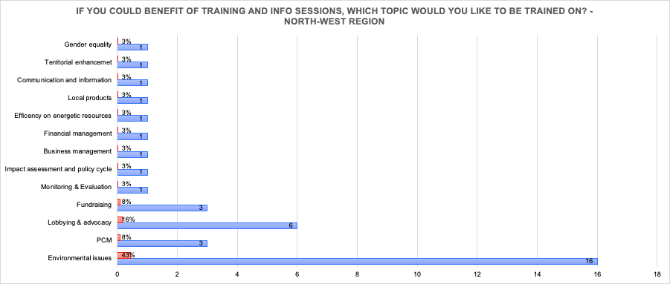

**Proposals** by the involved actors **to tackle** the above-mentioned environmental problems start from raising awareness in the public towards these issues and then call for more financial support to invest in innovative and sustainable solutions.

The proposed questionnaires also include some investigation on **womens’ role and engagement in the environmental protection** in Albania. The involved CSOs report almost perfect gender balance within their organizations, with a very high engagement of women in their working groups, mainly engaged as experts, but also in leading positions and supporting staff.

Almost 80% of the respondents report previous **collaborations with women associations**, mainly in order to develop partnerships and collaboration initiatives (38%), and to foster the integration of women on the job market. Others have promoted capacity-building training and women empowerment workshops. Despite the factual evidence stated above, the personal perception towards women actively engaged in the environmental sector is considerably lower than that of men. As shown in the graph below, many are the reasons why it is a common thinking that women have a hard time participating in environmental activities, for several reasons, all seemingly relevant.

**Figure 2. Factors that influence women's participation in environmental activities, North-West Region**

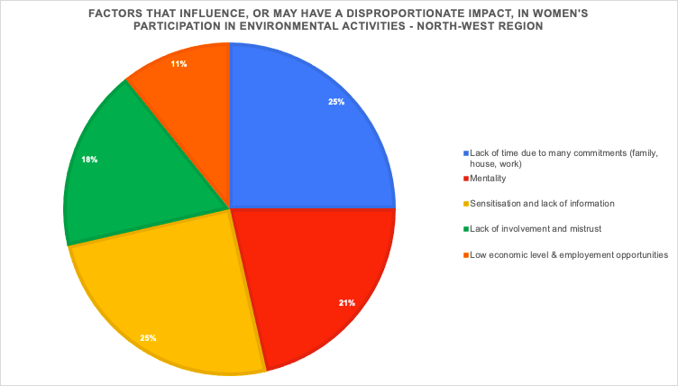

**Activists**

In the North-West Albania region 29 activists have responded to the questionnaires. Their engagement as activists in the region counts more than 10 years of commitment in environmental issues and most of them operate in the Region of Shkodra (93%) and the focus area of their activities is in rural areas (82.4%). As regarding their level of education 41.2% have obtained a bachelor degree and 32.4% a master degree.

The main reason of becoming an activist was aimed at environmental protection (64%), as mostly of them has been sensitive to the degradation of the territory and have decided to be the voice for the protection of their area, which need more sensitization for a sustainable development and efficient conservation of natural resources and to assure a better environment in terms of wellbeing and socio-economic development.

As shown in the graph below, the most pressing environmental issues that affect their area of intervention are the improper waste management (73.5%), followed by water pollution (47.1%), resource depletion (23.5%) and air emissions (11.8%), which are aligned also with the environmental concerns they address mostly, along with air pollution (35.3%), forestry (55.9%) and agriculture (26.5%).

**Figure 3. Main environmental issues according to activists in the North-West Region**

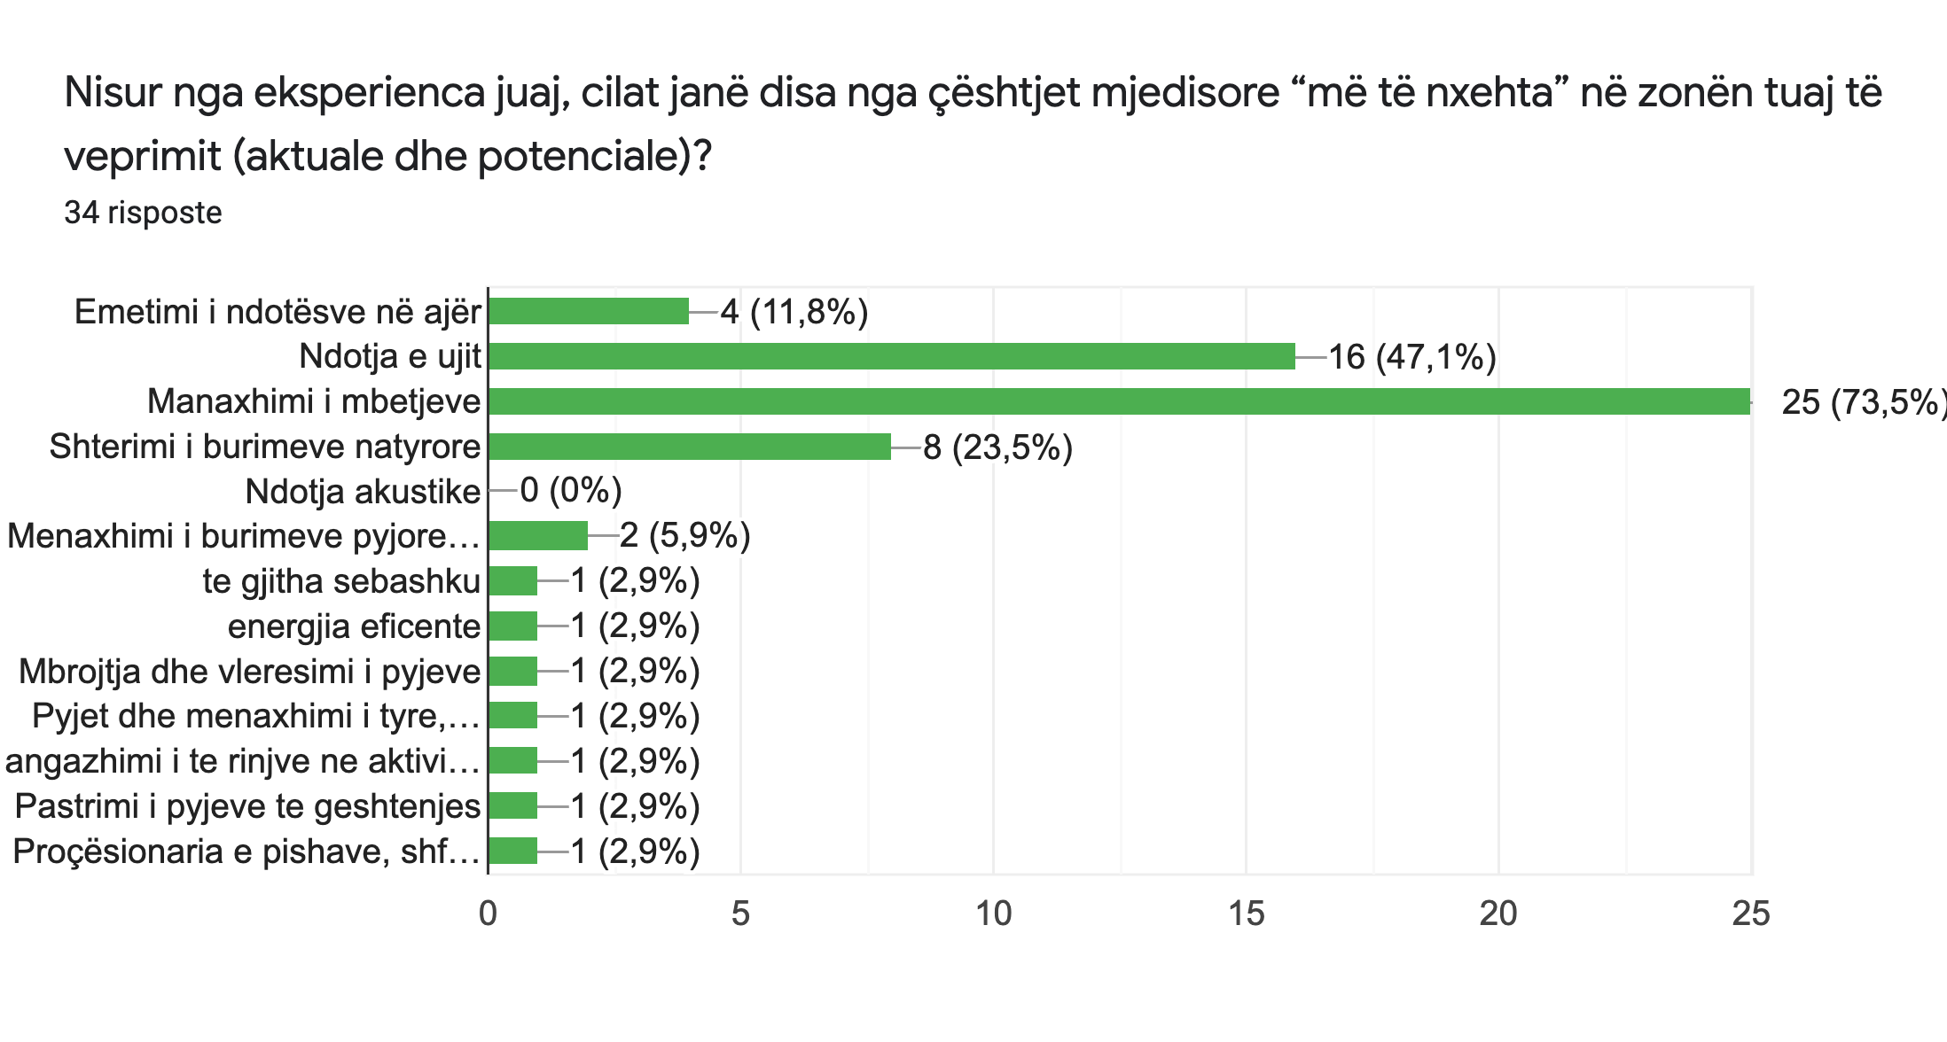

The engagement of activists is predominant in activities aiming the cleaning of the territory (47%), in raising awareness among the community (38%) and in activities aiming to the forestation of the areas where they act (15%). They also have attended different training sessions focussing on environmental issues and in campaigns against the construction of HPPs in protected areas and rivers. Awareness raising (44%) and the promotion of community initiatives (26%) are the most relevant achievements gained through their experience aiming at bringing changes in their communities and to foster environmental protection. In terms of environmental and economic development, eco-friendly businesses and activities have been initiated aiming for territorial enhancement, afforestation and youth activism.

In terms of their capacity building, 79.4% of activists have participated in training on environmental issues on themes, such as: green economy, waste management, clean technologies, forest and biodiversity conservation, strategic planning, PCM, fundraising, food security and sustainable farming.

The main concerns addressed to public institutions by 46% of activists are those inherent to waste management, deforestation, against the construction of HPPs in rivers and protected areas, degradation of natural resources, water pollution and air quality. Some of the concerns have resulted in signatures of resolutions and petitions on environmental impact issues or in drafting mobility plans, but on the other hand most of the concerns have not had a reaction from the public institutions or have been taken in consideration in later time. The activists who stated in the questionnaires that they have not addressed any concern is due the fact that they mistrust the engagement of institutions in these issues.

The responsible behavior in terms of environmental sustainability can be encouraged through law enforcement, awareness raising campaigns and encouraging voluntary environmental action by activists through laws that recognize the contribution as work practice. The local government should engage more in the creation of groups and voluntary initiatives, stimulating the participants with exchange experiences in different areas of Albania. The government should financially support CSOs and environmental projects. Schools must be involved in environmental education and a greater promotion should be done through media in regard to volunteerism and actions related to the environment. Of relevant importance is also the involvement of tourist and economic operators in the protection of the environment.

As regards exchange experiences with other activists’ communities, 52.9% have been part of this kind of activity implementing common activities on environmental issues (33%). Other activities are related to ecological days, training, participation in conferences and youth exchange activities.

The proposed questionnaires also included questions on the women’s involvement and role in environmental issues. There is almost an equal engagement of women and men in this regard (133 men and 155 women). The role that women hold is mainly as support staff (60.9%), but they have a significant role also in leading positions (52.2%) and as experts (30.4%).

The main sectors where women are directly involved are those of agriculture (64.7%), local products (64.7%), eco-friendly businesses (52.9%) and biodiversity conservation (29.4%), as these are the most developed sectors that require women engagement. On the other hand, women's participation in environmental activities is influenced by several factors, negative and positive: in some areas the mentality is an important obstacle, another one is the lack of time, as women generally have a lot of family commitments, especially when they are working also. While as a positive factor is to envisage the sensitivity of women in such issues and the commitment to achieve results in the initiatives they undertake. Also, their engagement in sectors as agriculture and agribusiness serve as an incentive of their participation in activities having in focus the environment.

**Figure 4. Sectors in which women in the North-West region are directly engaged in the management of natural resources**

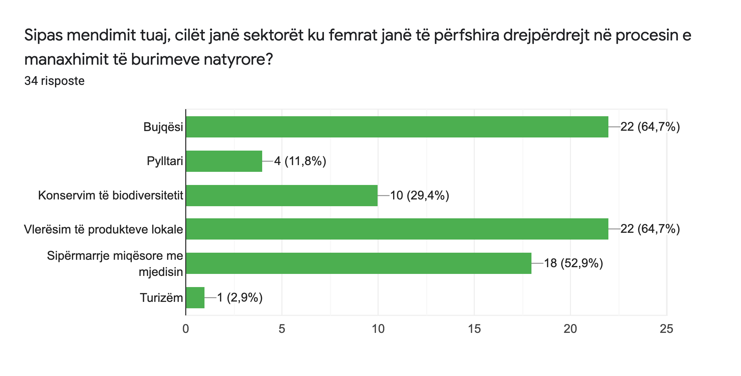

Of relevant importance to promote environmental responsibility is through education and awareness raising campaigns.

**Recommendations for sub granting processes**

The collected data suggest that many ECSOs in the region concerned prefer to apply for grants calling for single initiatives and intervention to the tackling of a specific issue (42% of the answers), followed by partnership grants, which invite private actors and public institutions to come together and tackle an environmental issue or provide an environmental-related service for the whole community.

**Figure 5. Expressed interest of CSOs per type of grant in the North-West Region**

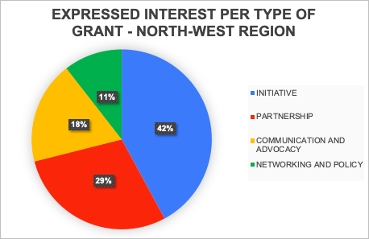

Recommendations that emerge from the collected data include:

* More technical training is required to accompany and guide the incubation and the grant implementation and monitoring: Even if a good percentage of ECSOs have already attended different training on PCM and advocacy, the concrete reality suggests a low number of projects presented and approved directly from them. This low rate of success should be considered during the trainings and shared with the experts that will be involved, to understand which have been the weaknesses in the other trainings and avoid the same errors.
* Lack of generational sustainability among local ECSOs is also to be considered, therefore the involvement of University and Academy in general is an important human bucket both in reinforcing advocacy papers and activities and in facilitating the meeting between ECSOs and possible new young members.
* Following up on the previous point, networking trainings and opportunities should be implemented to mobilize the beneficiaries and to foster the collaboration among CSOs, PAs, academia, to facilitate the sharing of know-how and environmental skills.
* Considered the gender topics, to foresee a dedicate expert for it, and define with him/her the main objectives of his/her consultancy: information and involvement of young rural women/girls. An initial strategy could be that of conducting trainings with time-schedules that would allow young people and women to participate, without subtracting them to other tasks and duties.
* Within the grant schemes, it is advisable to include environmental education sessions for different age ranges to raise awareness in all layers of the local communities.
* Considering the positive answers received from the activists in the region, the project could use their experience as best practice to be shared in and outside the region, enhancing even more their role and giving the opportunities to approaches new collaborators or stimulating new initiatives.
* Open topic remains the weak collaboration with PA, as both the direct data collected and the study by the expert confirm. Also in this case a good expertise in facilitating the preparation and good realization of partnership grants should be taken into consideration.
* Each call of application for grants should provide a non-exhaustive list of possible activities that the winner must include in the project proposal, so as to tackle specific needs identified through the needs assessment process.

1. **PROFILES AND RESULTS FOR NORTH-EAST REGION**
3. 1. **Kukës Region**

The **region of Kukës** (Albanian: Qarku i Kukësit) is one of the 12 prefectures of Albania and is located in the north-eastern part of the country. The region has a population of about 110,000 inhabitants distributed in 3 districts (multicommunal municipalities) and 24 municipalities. Since 1990, the population has experienced a drastic decline, around 30% of the population left the region and migrated to main urban Albanian centres and/or abroad. Kukes in terms of population is the smallest region in Albania.

The region has a relatively young population, the 0-14 age group represents 38.5% of the population, the 15-64 age group constitutes 45.9% of the total, while only 15.6% are over 64 years old. The main factors that have demographic developments are related to the economic transition: the closure of many state-owned enterprises and the related unemployment, transport, and communication infrastructures extremely poor, land generally difficult to access.

In 2010, the employment structure in the region shows that 19% of registered persons are employed in the non-agricultural private sector (services and industry) and 31% in the private agricultural sector. The rest (51%) is employed in the public sector.

The regional economy, affected by large-scale depopulation, has developed towards the exploitation of minerals, construction, and the service sector. There are still untapped opportunities in many sectors, particularly in tourism, agriculture and medicinal plants that do not affect the overall sustainable development and growth of the region.

The private sector is weak and non-dynamic, leaving scarce job opportunities mainly in traditional agriculture and in the public sector. Added to this is a low-skilled workforce which causes higher unemployment and limited opportunities, especially for young people, women and vulnerable groups. The high economic passivity of the population is particularly evident in women. The very weak, in some areas totally absent, social services net such as pre-school and education services in some rural areas reduce drastically the opportunity of social inclusion, participation and also social fabric empowerment and emancipation.

Kukes region despite its backward economic situation is characterized by unique natural resources and a culture heritage of its own.

The Region has several attractive natural and environmental resources including:

* Aquatic environments and water resources such as Fierza lake with a coast length of 80 km within the region, streams and rivers that flow into the Drin River, from Prespa and Pogradec lakes, from the Namuna mountains to the confluence of the Drin and Buna rivers. Lake Fierza is the center of all waterways and aquatic environments. Around its shores live a community of about 8000 families who have their interests directly connected to the waters of the lake. It is very suitable for growing fish of different species. However, as the main collector of all running water, this lake faces, most of all, environmental urban nature pollution. They are pollution of organic dandruff and leaching of agricultural soils. This involves, in addition to floating plastic waste, chemical contamination of the water with significant quantities of nitrogen and phosphorus.
* The unique landscape of the Albanian Alps, the well-known Valbona valley, which is increasingly becoming a destination for wild nature tourism, the canyons of Gryka e Gashit and Shishtavec, the skiing station of Shishtaves, and several sites of historical and cultural interest.
* The Korab-Koritnik Natural Park which stretches from the municipalities of Diber (20.663 2ha) to Kukes (34.886 2ha) and contains some 19.000 inhabitants, living within the natural part boundaries (Keci/Krog 2014:9). The K-K ecosystem hosts a rich diversity and density of flora and fauna, having several threatened fauna species, including big mammals like the lynx and brown bear, and critically endangered plants.
* A considerable stock of forests, which cover over the half of the region’s surface. Nevertheless, uncontrolled deforestation and logging despite of the existence of a protective legal framework had diminished the region’s resources.
* Many original ecosystems rich in biological and landscape diversity, including agriculture biodiversity. Linked to the floristic richness of these ecosystems, there is an extraordinary variety of medicinal plants that underlie a specific traditional activity of collecting herbs and producing essential oils and other plant extracts which are a great resource with still wide margins of recognition and growth. In the districts of Kukes and Has there was a real culture of tannins with a unique ability to recognize and distinguish them; an ancient tradition which also led enthusiasts to create merchandise collections. Today only few cooperatives survive for the collection, extraction, and processing of vegetable tannins in the area. In general, the plants are still traditionally harvested by hand and mainly by the villagers in the local territories and then sold to intermediary traders, none of whom are authorized controlled. Although it is known that there is the possibility of cultivation (and this would represent, at least for some vulnerable species, a decrease in the pressure on local biodiversity), local farmers do not grow these plants but continue to simply harvest them in nature.
  1. **Dibra Region**

**The Dibra Region** has a population of about 190.000 inhabitants and an average density of 68 inhabitants per km², which is lower than the country average. It includes 4 municipalities, 31 communes and 279 villages. Dibra Region is located in the northeastern part of Albania, in the central mountainous area, on both sides of the Black Drin River and Mat Valley.

During the last decade the demographic situation has followed the same trend as other north and north-east areas of the country, characterized by an overall depopulation due to rural-urban migration and migration to main urban Albanian centres and/or abroad.

In terms of economic development, agriculture, mining, fishing and forestry constitute the highest share (35%) of the regional Gross Value Added of which the main sector is agriculture (62%). Orchards and fruit trees planting characterize the region due to a very suitable climate for the cultivation of fruits. In general, the production of agriculture and livestock products and sub-products, are for domestic consumption, however there are some products that are destinated to market. These are primarily beans, meat and honey. The working age population at the regional level is at 53% of the total. Employment structure shows that private agriculture sector is the main employer, while a significant increase has been in private agriculture sector (by 56%) and private non-agriculture sector (by 45%), whereas employment in public sector has declined. Other sectors have some potential (mining, tourism) that remains unexplored. Growth in numbers of enterprises, although quite impressive does not compensate for losses in public jobs over the years. High economic inactivity of population is evident, and especially severe for women. Re-qualification efforts need to be greatly increased.

The region present number of families not self- sufficient and health and educational in particular vocational education, services are of poor quality, The region present a still high rate of social exclusion affecting in particular youth.

The Dibra region is characterized by:

* huge mineral wealth. Underground is rich in minerals like copper and chromium metal, but also with the construction and ornamental stones, marbles, inerts of river beds, caolinic clay,etc.. The most important mines that continue to operate are the chrome mines in Bulqiza and in the area around.
* Underground sources, rivers and glacial lakes which are of great economic and touristic potential. Even though data are not available, the water of these rivers is considered by the population of good quality and the pollution level (pollutants discharge and construction alongside) is low.
* The presence of river terraces, flat bottoms in highs which allow cultivation of a number of agricultural products. Most common products are potatoes, beans, apples, pears, plums, cherries, and nuts, etc., which constitute an important economic resource for the livelihood of the residents.
* National park of Lura, the Thermal Waters (Llixhat)
  1. **RESULTS**

Main constraints to sustainable development and environmental challenges

Kukes and Diber belong to the economically most disadvantaged areas. The high unemployment rate and the internal and international migration rate together with the very low number of families benefitting from social assistance pictures the state of economy in North Albania (INSTAT 2017).

Although there are local and regional initiatives on environmental protection in both regions, there is still much to be done. Among the priorities the following seems mor urgent to tackle:

- deforestation,

- biodiversity loss,

- poor water management,

- soil erosion

- overexploitation of natural resources

- waste management, throughout its all cycle, in particular for wastewater treatment and urban waste, remains one of the major problems in both regions.

Furthermore, a considerable part of the citizens is unaware of environmental degradation and damage and environmental education is not mainstreamed.

**Gender equality**

Both regions present weaknesses with regard to gender equality and more generally about the active participation of women in decision-making processes relating to sustainable development.

Among the main gender inequality causes the following are registered.:

* Lack of information;
* Mentality, community mindset
* Prejudices and stereotypes.
* Lack of economic independency
* Low level of quality education
* Scarce opportunity of accessing to quality vocational education

The project through its activities will aim at addressing also gender equality issues strengthening ECSO, internal and external, in mainstreaming gender in their activities and it will favor high women participation to training and incubation process that will be planned in the coming months.

The grant scheme that will be set up will pay particular attention to embed gender equality concept and practices.

**Regions Strengths and Limitations**

The limitations are, on one hand, mainly linked to COVID 19 restrictions on mobility and people gathering and, on the other hand, are more linked to technical aspects such as lack of scientific data about environmental issues and evidence based analysis about habitat and biodiversity status to support the identification of nature based solutions to environmental challenges.

Key Findings

*This section summarizes the analyses and findings from the process. A bulleted list is easier to read and act on over a lengthy narrative.*

In the Region of Kukes and Dibra the majority of the respondent ECSOs (16 in total) and respondent activitst (14 in total ) have been active for over 10 years Only some have been established in the last 5 years. There are few ECSO with more than 20 active members.

The percentage of women and men is quite balanced, the roles covered by women vary from staff to volunteers, but it is important to point out that the percentage of women holding a managerial role is 43%, and the 86% has the role of expert.

**Figure 6. Number of members of CSOs in the North-East Region**

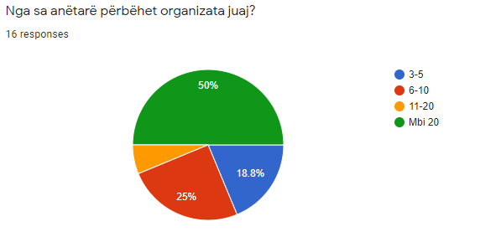

Most of the members of ECSO and activist has a high education degree, among them we can find biologist, Environmental Engineer, and agri-environmental engineer.

The respondents are involved in various sectors in the environmental field, including the protection and sustainable management of water and water waste, air pollution, waste management, environmental awareness, and information and in general nature protection. Among other sectors tourism and rural development have been pointed out while activities related to renewable energies, climate change, biodiversity and environmental legislation are less developed. Activists have also outlined the territorial management and planning as one of the most important aspect of their activities.

The activities carried out and managed are mainly developed in the most populous areas of the regions and less in the more remote rural areas. Some of them carry out activities and projects also in Tirana and in other areas of the country in collaboration with other associations and activists.

Among activists the number of individuals engaged in more remote rural areas is higher.

All ECSO and single activists collaborate with each other and with various stakeholders including local governments, national institutions, small and medium-sized enterprises. collaborations with universities and schools are less frequent while there are very few collaborations with local and national media and with large companies. Some of them have also good collaboration experience with international organizations and UN agencies.

The 48% of the respondent have good experience on gender equality issues such as women rights and professional education, land property and its management from a gender perspective, women participation in decision-making bodies, and women entrepreneurship development. Moreover, all the ECSO and also activists affirm that the number of women engaged and participating in the environmental sector is significant.

The sources of funding for most of the ECSOs are funds from international donors, subgrants from civic associations and local governments. Funding by national institutions and by companies are a very low percentage.

As per internal capacities most of the organizations are driven by a lot of commitment and passion and declare that they know how to develop projects but at the same time they state that they do not have high technical skills both in the search for funds and in the project management.

Among the issues that most report for possible training opportunities are:

* Environmental legislation and EU approaches,
* Waste management
* sustainability
* Project cycle management and donor’s rules
* Good practices on environmental issues and natural resources sustainable use
* Forest fire protection and Forest management techniques at local level
* Renewable and alternative energy sources for livestock farming in remote areas
* Conservation and environmental protection of pastures.

For future project, the areas that ECSO and activists mention as primary issues to be promoted are:

* Community participation and mobilization on environmental protection,
* environmental education
* exchanging positive experiences
* youth engagement in environmental protection and environmental crime
* education
* Creation of green areas and protected ecosystem
* Definition of policies at local level
* Networking and political dialogue with all competent stakeholders

The Green Al project, structure and main components, has all the potentials to respond to the needs of ECSOs and activists to address critical issues and environmental challenges that the territory presents, but in the same time the project activities should be more oriented on **raising awareness of the civil fabric as a whole, directly and indirectly affected by environmental problems, in order to create a more solid critical mass to be more supportive of advocacy and policy orientation initiatives**.

Furthermore, environmental education appears as a priority starting from school groups up to public officials, including the largest number of people. Consequently, information and sensitization campaign should be included in the subgrant guidelines as an asset for project evaluation

With the aim of **strengthening internal and external capacities of ECSO and activists** a comprehensive capacity building, including incubation process during subgrant project implementation, seems to be a priority, and the main topics should be:

Internal capacities:

* Project cycle management
* participatory approaches and community mobilization
* stakeholder’s analysis and policy dialogue strategies
* networking and communication

External capacities

* Advocacy (problem analysis, solution findings and knowledge/evidence based data utilization for policy orientation )

1. **PROFILES AND RESULTS FROM SOUTHERN REGION**

The Southern Region of Albania, which is one of the areas where the Project is implemented, in general manifests the same patterns of the problem that are also present in the civil society and environmental sector country-wide. In this context, there is a lack of critical mass among grass-root CSO-s due to weak internal organizational capacities, a fragmented and ad hoc cooperation between organizations, a limited scope and depth of activation of the civil society and the application of a top- down approach of governance decisions that often goes against the acquis requirements and diminishes their ability to impact.

According to the findings of ACAP Project (Community Action for the preservation of Protected Areas), Albania, and in this case the Southern Region where Vlora, Korca, Berati and Gjirokastra are situated, has a natural heritage manifested in exceptional ecosystems that need protection, but also represent an enormous potential for the sustainable socio-economic growth of the country. Some of the most well-known National Parks and Natural Reserves are located in this region, such as (Tomorri Mount, Llogara Park, Bredhi i Hotoves Park, Nature Reserve of Vjose-Narte, Prespa National Park ect), and while they have obtained the status from the government, they still aren’t managed in an optimal way, resulting sometimes in a condition of neglect and danger of irreversible damage. This lack of adequate management derives from low structural and financial capacities, as well as low levels of community awareness and activism for the importance of such resources.

On the other hand, there many are other areas of natural value such as water resources that haven’t been valorized or given a protected status, and therefore the challenges related to their protection are still not brought to the agenda with the deserved prominence. In this situation, a process of Needs Assessment targeting local organizations and communities is viewed as a crucial step in order to properly design the support mechanisms envisioned in the project, through integrating the original input from the grass-root level towards the shaping of a response tailored to the specific needs and challenges related to environment that are faced locally and nationally.

Here below we report a list with the main environmental priorities for each of the southern areas covered by COSV in the frame of the project.

* 1. **Gjirokaster Area**

The Vjosa is reputed to be the last big wild river in Europe, outside Russia. Entirely unobstructed, she flows through inaccessible gorges and sections with enormous gravel banks and islands on her course of almost 270 kilometers from the Pindus Mountains to the Adriatic Sea. The Albanian government under Prime Minister Edi Rama intended to have a Turkish company construct a hydropower project within the ecologically most valuable stretch of the Vjosa. The project “Poçem” would feature a 25 meter tall dam wall. A group of scientists from Albania, Austria and Germany has called for a three-year moratorium on all construction plans on the Vjosa and its tributaries, in order to allow for the implementation of an interdisciplinary research and assessment program on the Vjosa River. They suggest the Vjosa could serve as a “large-scale natural refuge and laboratory of pan-European significance” and an international reference site for climate change research. Also, instead of hydro exploitation, campaigners believe that the Albanian government should develop eco-tourism opportunities along the Vjosa and generate power from other renewable sources such as wind and solar. With 265 days of sun per year, Albania indeed has a high potential for solar power generation. The org Friends of Vjosa demand:

* The cancellation of all hydropower plant concessions that are planned or are under construction on the Vjosa River and its tributaries.
* The proclamation of the entire Vjosa Valley a National Park, which would be the first Wild River National Park in Europe and it support economic development of the entire valley.
* To be taken in consideration the demand for a 3-years moratorium on hydropower plants on the all Albanian rivers, which would give to the experts and decision-makers enough time to evaluate in a scientific and rational way the benefits and losses from the construction of these hydropower plants.
* The drafting of a National Master Plan that would define, the “go” and “non go” areas where the hydropower plants should or should not be built.

The Prime Minister of Albania, Edi Rama, announced in September 2020 that the Kalivaç dam will not be built. Following the Prime Minister's message, this is the right time to start a dialogue with scientists, public authorities and civil society about the future of the Vjosa and the creation of a Vjosa National Park.

* 1. **Berat Area**

A Decree of the Council of Ministers no. 472, dated 18 July 2012, proclaims the natural ecosystem of the Tomorri mountain protected area on an area of 24.7 thousand hectares. According to the DCM this area includes the municipalities of Roshnik, Vërtop, Bogovë, Gjerba, Zhepë and Kushovë. In 2014, the government approved a management plan for the Tomorri National Park. The plan defines the stone quarrying business as a real threat to natural habitats and geological features of the area. “It is necessary to close unlicensed quarries, excavations within the park area,” the 150-page document warns. With decision n.467, dated 26.7.2018 "On the expansion of the national park" made by the Government, the National Park of Tomorri Mountain in its surface is already included 12 quarries which were located outside the area of the National Park.

In July 2019, the Tirana Administrative Court of Appeal declared the government decision illegal, reasoning that the community was not asked about this decision, and demanded that the companies that destroyed Mount Tomorri could return to work. Not long ago the ban on work on Mount Tomorri was accompanied by much debate and it seems that lobbying managed to overturn a government decision.

The national road from Poliçan to Novaj village, about 7 kilometers long, is overcrowded by stone processing factories. There are around 15 companies that deal with the extraction and processing of stone tiles. Each one emits 30 to 50 thousand cubic meters of stone, which is traded at a price of 30 euros per square meter, destined mainly for the foreign market. The Regional Administration of Protected Areas in Berat, states that the institution he leads is impossible to monitor the activity of these companies. According to several ecologists, Quarries in the Tomorr National Park have started early and now are scattered and are damaging it as it damages the mulberry tree and where they have developed, they have irretrievably destroyed the ecosystem in the area.

Other Major Environmental Challenges in Southern Albania

Shell Perforations in Mount Shpirag: Industrial contamination on Osum River from leather and oil factories, water and waste management etc.

* 1. **Vlore Area**

Deforestation of Soda Forest; Presence of the La Petrolifera Italo Albanese Sh. A. (PIA), which manages a coastal depot for LPG (Liquefied Petroleum Gas), Oil, its derivatives (Diesel, Gasoline, etc.) and other goods, both liquid and solid, in the Bay of Vlore; Saline Impact in the Narta Lagoon; Mercury Contamination of Zvernec Seaside; Vlora Airport Construction; Waste Management; Sewer water discharge into the sea ; Ships and ferries ballast water discharges in the bay of Vlora; Water Manegement; Soul degradation; Massive Touristic flaws in Karaburun Peninsula; Resort Building in Vjose-Narte Area

* 1. **Korce Area**

Water and Waste Management; Atmospheric pollution from wood heating, deforestation, nickel pollution of the shore of Lake Pogradec, electromagnetic pollution, fuel pollution deriving from vehicles, falling of water level in Lake Prespa as a result of falling snow and precipitation level, lack of a landfill at t a county level.

* 1. **RESULTS**

**Gender Mainstreaming**

A gender mainstreaming perspective is implemented in the Need Assessment process, by including questions which intend to receive gender segregated data and also by involving men and women equally in the process. In this framework, gender mainstreaming is embraced as an integral part of the project, since a qualitative change will be made in the Incubation program, in which a dedicated number of capacity building trainings with the ECSO-s will tackle gender mainstreaming topics and strategies.

**Furthermore, the sub-granting schemes will be adapted through establishing guidelines that will push the organizations to institutionalize principles of gender mainstreaming internally.** Also design projects that integrate a gender mainstreaming perspective in terms of contributing to the provision of gender sensitive information on environmental protection as well as the collection of gender segregated data, the facilitation of a dialogue on gender equality in the environment sector, the promotion of women participation on decision-making and equal employment opportunities for men and women etc.

Furthermore, the components of this strategy will be fine-tuned based on the NA reports, further developing the set of mechanisms and incentives that will be integrated in the Incubation and the Guidelines for Grant Schemes, in order to promote gender equality and gender responsive models among the grass-root CSO-s, activists and also in the local communities through their projects.

***Regions Strengths and Limitations***

*Description of the main strengths of the process (for example, a large number of archival data sources were available), as well as any considerations the audience should be aware of as they read and interpret the key findings (i.e., poor participant response rates on parent surveys).*

As regards to the strengths manifested in this process, the most significant one is the effective exploitation of previously established networks by COSV in the targeted Region, which has facilitated the cooperation and the timely sharing of information and data online.

The most pressing limitation is related to the pandemic situation, which has significantly restricted the access to physical meeting of large audiences which would be far more productive and constructive, bringing added value to the outreach and orientation activities.

In addition, taking into consideration the duration of this situation of pandemic restriction and the large number of intense and continuous online meetings and surveys in which CSO-s have participated during all this time, this might have influenced the data collection in a sense that not everything might be explained in detail and in an exhaustive way.

**Key Findings**

*This section summarizes the analyses and findings from the process. A bulleted list is easier to read and act on over a lengthy narrative.*

**ECSOs**

In the regions of Vlora, Berati, Korca and Gjirokastra the majority of the ECSO (25 in total) who are among the respondents of the NA Questionnaires have been active in the field for a significant time, with around 64% of them having more than 10 years of experience, and moreover, 50% of this group of organizations with the longest presence registers an activity that is ongoing for over 20 years. A small number of ECSO-s has been established in the latest period, which shows that the interest in contributing to the civil society sector for environment protection is constant and renewed also through new comes in the field. A substantial part (64 %) of the respondents report having more than 10 members in their official structures, while 34 % of the total number declare a membership status of over 20 people. The membership of other 28% is constituted by 6-10 people. With regard to the number of men and women members of ECSO-s, the data shows that the number of women is higher, while, as showing in the graph illustrated below, more than 50% of the organizations report that the latest are engaged in leading positions as well as support staff (an additional 35% of ECSO-s engage women as experts).

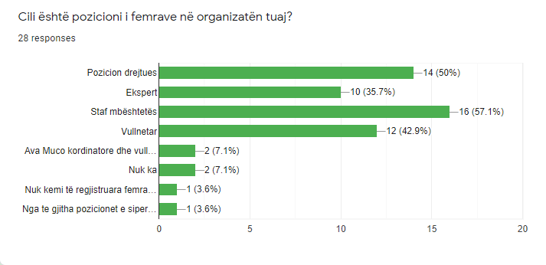**Figure 7. Women's position in CSOs in the Southern Region**

It is notable that 75% of ECSOs in the Southern Region address mainly issues such as awareness raising and environment protection, but topics including waste management, forestry and the preservation of natural resources are also covered by a majority of more than 50% of ECSO-s in the area. Issues such as climate change, energy and biodiversity are reported as a priority of intervention by closely 25 % of the respondent organizations.

**Figure 8. Environmental concerns mostly addressed by CSOs in the Southern Region**

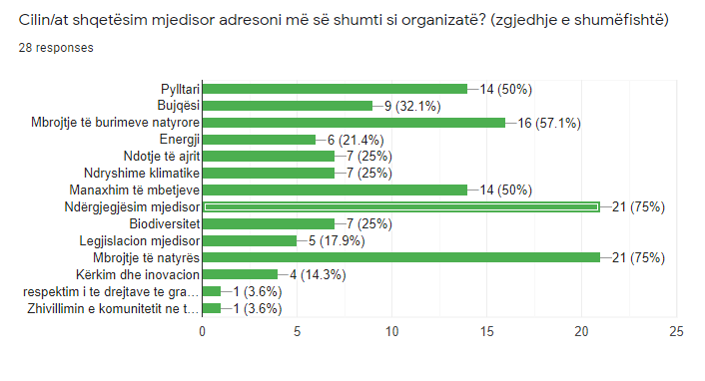

Around 93 % of ECSOs active in the area respond that they work together with other actors, among which the predominant partners appear to be other CSO-s and local authorities, which respectively are represented in the data as collaborators for 96 % and 89 % of the total respondent entities.

Other reliable collaborators for ECSOs (46%) appear to be the national institutions, while local businesses are mentioned by around 27 % of respondents.

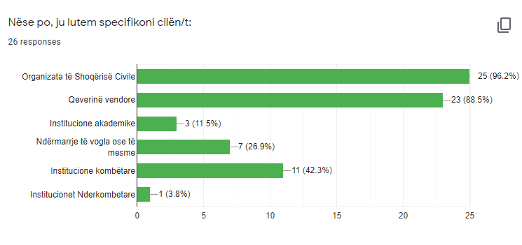**Figure 9. Level of collaboration between CSOs in the Southern Region and other actors**

More than half of the respondent ECSOs declare to have collaborated with organizations who promote women empowerment and gender equality, and in this direction the most noteworthy answers reflect joint actions towards the empowerment of women in rural areas, promotion of the role of women in the tourism sector especially by supporting their entrepreneurship initiatives, and environmental awareness raising and educational campaigns targeting local women.

**Figure 10. Collaboration of CSOs with Women Empowerment organizations in the Southern Region**

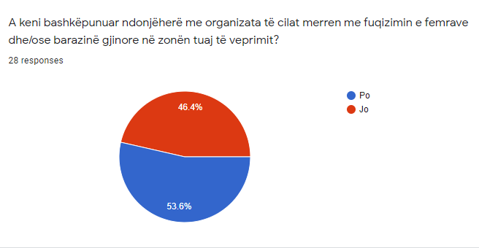

When it comes to funding sources, an abundant majority (79%) report grants by international donors as the most common one, followed by sub-granting opportunities by CSO-s (46.4%).

**Figure 11. Main financial resources of CSOs in the Southern Region**

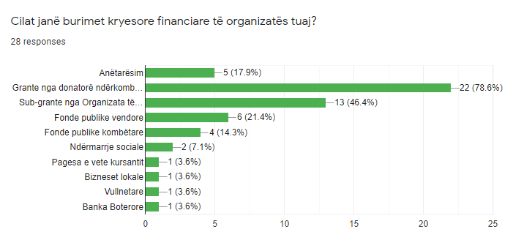

In the last 5 years, in the target areas the ECSOs have implemented local environmental projects that are mainly focused on awareness raising, promoting sustainable tourism, supporting rural women, planting trees, preserving natural resources with a special focus on Protected Areas, innovative waste management, environmental education, capacity building on environmental services, strengthening advocacy and lobbing on environment issues, and supporting green enterprises.

Half of the ECSOs declare that they have information on successful initiatives and actions by ECSOs happening around their area, and the most noticeable examples mentioned include: local petitions, CSO *ad hoc* networks for monitoring specific issues, awareness raising campaigns, promotional campaigns, advocacy at local level etc.

It is noted that 50% of responses state that women are affected by the negative consequences of environmental issues, and in addition, among the factors that condition women’s participation in the environment activities we find: mentality, oppression by male authority ,traditional patriarchal norms and gender roles disadvantaging women, gender inequality in household care responsibilities resulting in lack of access to time for women, indifference and failure by public authorities in supporting and promoting the role of women as crucial factors in the sector , large distance of certain rural areas and lack of optimal transportation and connectivity, lack of information among women etc.

Even though more than 78 % of ECSOs admit to have benefited from trainings on environmental topics and project design and management, most of them report a significant need and willingness to participate in future trainings on PCM, resource mobilization, monitoring and evaluation, communication and outreach, environmental legislation, community mobilization, financial management, gender mainstreaming, relevant environmental issues, innovative solutions, advocacy , lobbing , policy influence etc.

The most pressing environmental issues identified by ECSOs in their areas are: low environmental awareness of citizens, deforestation, waste management, soil and water pollution, air pollution, preservation of natural resources etc.

With reference to policy influence related action, 57% of respondent entities state that they have participated in meetings and consultations held by public authorities on environmental decision-making processes.

In the end, the data indicates that around 78% of ECSOs in the Southern Region are interested in applying for Initiative Grants, 46,4% of them choose Communication and Mobilization Grants, around 43% express eagerness to apply for Partnership Grants while another 35 % of respondents see themselves more attached to Networking and Policy –Influence Grants.

**Activists, local businesses and academia**

A number of 26 questionnaires have been submitted by environmental activists, local businesses and academia representatives in the regions of Vlora, Korca, Berati and Gjirokastra and the majority (76%) of the respondents appear to be engaged and acting in urban areas. When referring to the status and modalities of their activity, 60% of them state that they act individually, while among those who are engaged within associations, 78% report that these structures are formally recognized according to the Albanian laws.

On the other hand, it is made evident that these associations are structures in which both women and men are engaged for common action.

**Figure 12. Gender composition of the associations in the Southern Region**

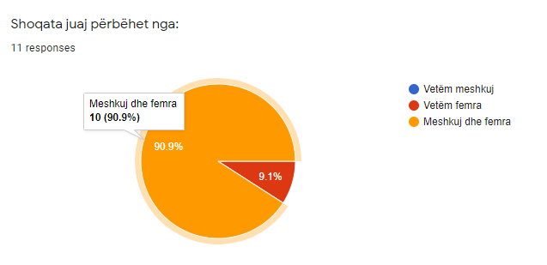

Data shows that 44% of respondents believe that women are affected disproportionally by the effects of environment pollution, while 48% of them see this issue as one affecting both women and men equally.

With regard to the reasons why they have decided to become environmental activists, the most specified reasons consist of: the connection with nature and the sensibility on the problems affecting it; the drive to raise awareness on pressing environmental issues that are seriously putting at risk the health ,quality of life and the future of the communities ;the perception of an urging need to promote sustainable management of natural resources as well as biodiversity; the perception of the importance of advocating to sensitize public authorities, and setting environment protection as a priority in the local agenda; the attachment of the topic to tourism development as a key sector for Albania etc.

As illustrated graphically here below, the collected data gives us the information that the most pressing environmental concerns identified by the respondents are waste management (72%), water pollution (56%) and the degradation of natural resources (32%).

**Figure 13. Main environmental issues addressed by activists in the Southern Region**

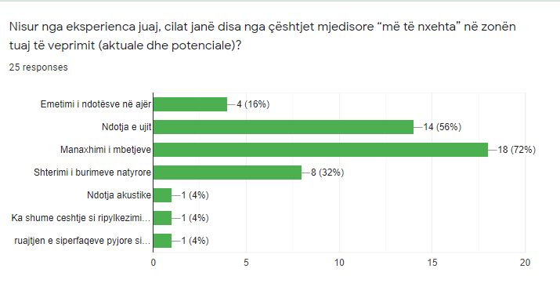

In this context, with regard to the issues they are directly addressing through their interventions, the aforementioned subjects emphasize waste management (76%), water resource management (48%) and forestation (56%) as their priorities.

When self-assessing their engagement, activists highlight as the most successful activities the following : impactful awareness raising campaigns targeting local communities with regard to responsible environmental behavior, effective safeguard of certain local resources and constant denouncing to relevant authorities, sensitizing of local actors on the rehabilitation of waste deposit locations, community education on alternative waste management and activism for environmental rights and services , contribution to forestation through volunteering, community based fund raising on supporting environmental actions, expertise on monitoring endemic species of special value and design of plans for their protection , preservation and promotion of Protected Areas, women empowerment in environmental decision-making etc.

As regard their capacity- building options, 60% of activists demonstrate to have participated in trainings on environmental topics and project management aspects.

**Figure 14. Level of participation of activists on environmental topics in the Southern Region**

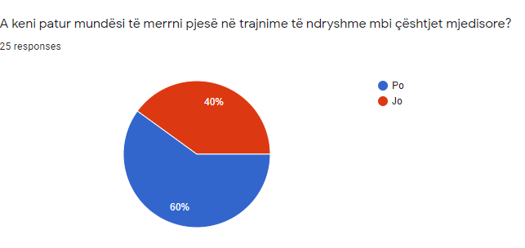

The respondents claim to have reported various issues to public authorities, and in situations that were more acute the institutions have reacted positively by solving the problem, while with regard to more chronic ones still the measures taken seem to be flawed and mostly ineffective. Activists deem that education, awareness raising campaigns, media and fines are very important towards achieving the adequate environmental sensibility and behavior.

In conclusion, 68% of respondents in this category state that public institutions have a good approach on encouraging a responsible environmental behavior in the society, but still this approach needs to be strengthened with stronger mechanisms and a more comprehensive and sustainable strategy, and therefore make environment protection a major priority in the agenda.

**Recommendations for Logic of Intervention modifications**

The results are needed to be modified with the finalization of this first phase, with a purpose of achieving a strengthened results-based management approach, that will ensure a more effective intervention based upon a stronger and clearer correlation among the outcomes, outputs and the respective activities, and therefore an improved system of performance measurement.

In this context, an improvement is advisable to be done in the capacity building outcomes and activities, which consists of a differentiation between the technical aspect, the internal governance one and also the outreach as well as partnership building on the other hand, while more attention is necessary to be paid to promoting gender equality on a cross sector basis. The policy influence oriented aspect is considered to be enriched with a more complete set of indicators that will guide the efforts and performance.

**Technical trainings seem to be a must when targeting local ECSO-s in terms of project management, partnership building, community mobilization, networking, communication, advocacy as well as policy influence.** It is also crucial to provide trainings on all the environmental topics that are highlighted in the findings section of this NA Report, as there is a notable need to build capacities in expertise terms with the aim of creating conditions for ECSO-s to propose innovative models and solutions, as well as to be a factor for change through evidence/based and advocacy.

Furthermore, it is recommended that the Incubation training program and the sub-granting schemes should be adapted through establishing guidelines that will push the organizations to institutionalize principles of gender mainstreaming internally, and also design projects that integrate a gender mainstreaming perspective in terms of contributing to the provision of gender sensitive information on environmental protection as well as the collection of gender segregated data, the facilitation of a dialogue on gender equality in the environment sector, the promotion of women participation on decision-making and equal employment opportunities for men and women etc.

The data that emerged are mainly in line with expectations in the southern areas of the country. There is indeed a need to pay greater attention to gender issues also in the field of environmental protection and to include women more in the internal decision making of CSOs but also at EU and institutional level.

As a result, and in light of the implementation of the Gender Analysis, of the various workshops on the subject and of the exercise carried out together with partners with the purpose to align this aspect as much as possible with the result chain of the project, we believe that the activities can remain the same as foreseen in the full Project Proposal but streamline a minimum in terms of deliverables and re-allocate according to the new configuration of the log frame.

In summary, COSV proposal would be to review and slightly increase the financial resources at disposal for the expertise (mainly but not only) related to gender mainstreaming, which would help the partners to effectively deliver such kind of intervention at a local area and consequently link this component to the rest of the project chain.

1. **PROFILES AND RESULTS FOR CENTRAL REGION**

The central region under the supervision of Co-PLAN, the Institute for Habitat Development includes the territories of the qarks of Tirana, Durres, Fier and Elbasan. It is worth mentioning that in fact this region is one of the most dynamic at the national level as most of the population is mainly concentrated in these territories due to the provision of services and major economic and social activities. The process of urbanization in these areas has been and continues to develop rapidly within a short period of time resulting in habitat loss and degradation of all environmental elements that characterize this region. In general terms, for all municipalities in Albania, the main challenge remains the integrated management of urban waste and pollution of water bodies due to the lack of wastewater treatment plants and uneven distribution of the sewerage system, especially in rural areas. For the region in question, these issues remain a particular challenge due to the high number of consuming population and where consequently a better allocation of basic services is required.

* 1. **Tirana region**

Tirana region which includes the municipalities of Tirana, Kamza, Vora, Rrogozhina and Kavaja, is the territory where the economic pressure is clearly observed as well as a variety of relief starting from the mountainous terrain with “Gropa Mountain” described as a Protected Landscape of national importance and up to the coastal area of the territory of the municipality of Kavaja. However, what has been observed over time is that economic development and urbanization have negatively impacted the achievement of sustainability by significantly undermining almost all environmental elements of the area.

The Municipality of Tirana, Kamza and Vora, according to the respective Local General Plans, focus the main environmental problems on the high level of air pollution, noise and reduction of public green spaces as a result of construction activity, public transport and heavy traffic from infrastructural interventions. On the other hand, the municipalities of Rrogozhina and Kavaja, being very similar in terms of territory and development dynamics, have the same threats related to the degradation of agricultural lands and pollution of water bodies (in this case the Shkumbin River and the coastal area along the territory of the municipality of Kavaja).

* 1. **Durrës Region**

Durres region is also a diverse territory, consists of the municipalities of Durrës, Krujë and Shijak. Although it is currently a potential municipality in terms of economic development thanks to the development of the tourism sector, Durrës over the last 10-15 years has shown great losses in terms of public spaces and leaving room for the concreting process by increasing thus the possibility of more frequent floods also influenced by the effects of climate change. Another concern is related to the pollution of coastal areas that comes as a result of the lack of public underground sewerage infrastructure and urban waste management, considering mostly the period of the summer season. In fact, the lack of wastewater treatment plants has led to indirectly (via rivers) they discharge into the sea. The Erzen and Ishëm rivers flow into the territory of the municipality of Durrës, which according to the State of the Environment Report 2019 (SER) are among the most polluted rivers in the country. Therefore, the crossing of the Erzen River along the territory of Shijak municipality and its poor condition from urban waste and uncontrolled extraction of aggregates has significantly degraded agricultural lands thus affecting their productivity. As mentioned above, the municipalities in this region have different relief and consequently have different tendencies in terms of environmental aspects. Qafshtama National Park is included in the territory of the municipality of Kruja and is one of the most important forest areas and also most endangered by the process of uncontrolled urbanization.

* 1. **Elbasan region**

Elbasan region consists of seven municipalities (municipalities Elbasan, Librazhd, Cërrik, Peqin, Prrenjas, Gramsh, Belsh), lies in the central area of ​​Albania and occupies a territory of 3199m2. With a population of 295,827 inhabitants, this county suffers from some very important environmental problems which cause pollution and concern for the inhabitants.

Some of these problems are related to pollution that comes mainly from industry but also from the used vehicles, construction industry, infrastructure, waste management, deforestation, etc.

In the municipality of Elbasan the main problem is related to the operation of the metallurgical complex from where significant amounts of pollutants are discharged such as heavy metals and many other chemicals. Also in this municipality are some areas with high level of pollution (known as environmental hotspots) which cause continuous emissions and pollution of air, water and soil. Some of these areas are the former Ferrochrome Smelting Plant, the Industry-Mining Supply Company in Balëz (where 30 tons of Cyanide are produced), the Explosives Plant (the surrounding area is polluted with explosives and heavy metals such as Pb, Cr, Cu, Mn at very high levels), cement factory in the Industrial Zone, etc.

Another problem that belongs to the municipality of Elbasan but also to other municipalities of this region has to do with the creation of illegal landfills and dumping of waste along the river Shkumbin. In this district a big problem is mismanagement and massive illegal deforestation.

Other problems are the use of depreciated motor vehicles, discharges into the river of polluted water, high erosion, mismanagement of water resources, indiscriminate use of aggregates in the river basin, etc.

* 1. **Fier region**

**Fier region** is located in the southeast Albania. it is located in the center of the country surrounded by hills. The city is located some 16 kilometers east of the Adriatic Sea and 100 kilometers south of Tirana.

Fier region occupies 10.3 % of the total population of Albania in 2021, being the second largest region in the country after Tirana. Fier is one of the main economic regions in Albania. It occupies almost 10 % in the structure of gross domestic product (GDP) in Albania for 2021, giving a contribution in real terms to 2015 of minus 0.50%, while GDP per capita was higher than the national average of 530 thousand ALL. The number of enterprises in this region reached 20,818, which ranks it second in the country after Tirana.

Fier region has a rich water network. Its territory is crossed by the lower course of the rivers Seman, Vjosa and Gjanica which flows into Seman. Vjosa and Semani are distinguished for abundant water sources during the winter season. Semani traverses the Municipality of Fier in a north-west and south-east direction with a length of 40.3 km. Throughout the territory of the municipality, the Seman River creates numerous windings, taking the form of a cone with twisted borders. In addition to the rivers, the municipality is distinguished for a network of irrigation-drainage canals very important for agriculture that is cultivated in the area of ​​Myzeqe throughout the year. The results of water monitoring show that the waters of the Vjosa and Seman rivers are deeply polluted with heavy metals. Sources of pollution are various, mainly human activities (*oil industry, polluted nitrogen underground, landfills, agriculture, etc*.)

According to data pollutants in the air from the above-mentioned pollution sources are SO2, H2S CO2, water vapor and carbon waste. The areas of the Municipality of Fier, which are located very close to the areas of the polluting industry are very exposed to smog, causing not only damage to the environment, but also to human health. It is not uncommon for people in these areas to suffer from various carcinogenic diseases, mainly in the airways. On the other hand, due to the fact that waste is deposited without any criteria, methane emissions are present all the time, posing a concrete risk to the health of residents in the area. Considering the large number of sources, which cause air pollution in the city of Fieri as well as the norms of pollutants above the allowed standards of the EU and those of Albania, the Municipality of Fier must show special care in reducing air pollution, mainly from oil wells, adding buffer (*protective*) areas around them.

Levan Park is located in the territory of the Municipality of Fier with an area of 200 ha. It represents a typical renewable oak forest, where reforestation with Mediterranean pine species is not lacking. This area is not distinguished for any biodiversity diversity, but it is important for landscape protection and tourism development. Currently this area has no management plan.

Based on the questionnaire’s replays developed in the region of Fier, the main environmental problems highlighted are:

*1) Air pollution in urban areas;*

*2) Urban solid waste management;*

*3) Noises;*

*4) Water pollution;*

*5) Lack of respect and commitment to environmental issues;*

*6) The economic development model does not include environmental issues and environmental integration;*

*7) Illegality against natural resources (deforestation, deforestation, river pollution, dumping of waste along the road, etc.);*

*8) Excessive urbanization in the city and lack of green spaces / Lack of sustainable planning / Lack of quality monitoring;*

*9) Habitat reduction and biodiversity loss. Disruption of balances in ecosystems by changing physio-chemical components;*

*10) Poor municipal services in the environment;*

*11) Natural resource management;*

* 1. **RESULTS**

More than 1/3 of CSOs consist of more than 20 persons.

**Figure 15. Number of members of CSOs in the Central Region**

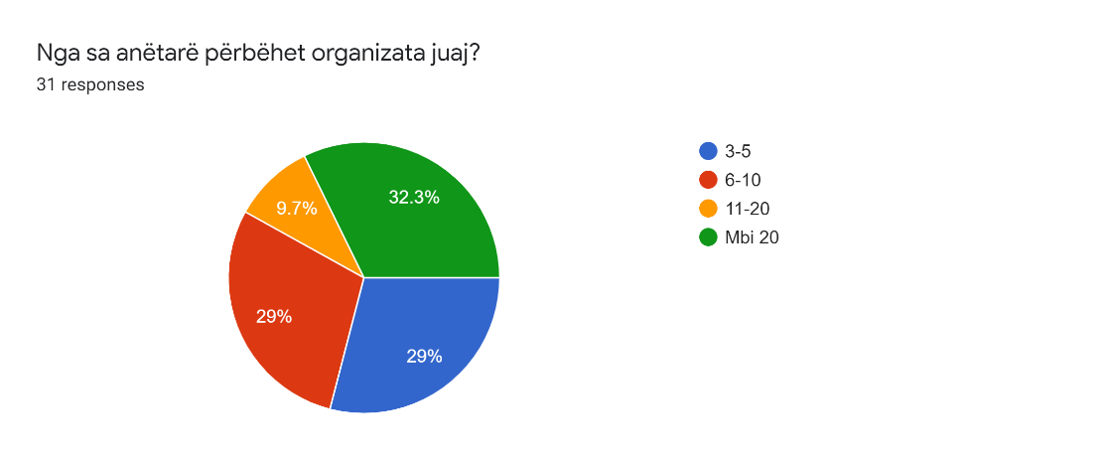

Most women working in CSOs are in support staff positions.

**Environmental concerns that are mostly addressed from organizations:**

*1) Protection of natural resources;*

*2) Environmental awareness;*

*3) Nature protection;*

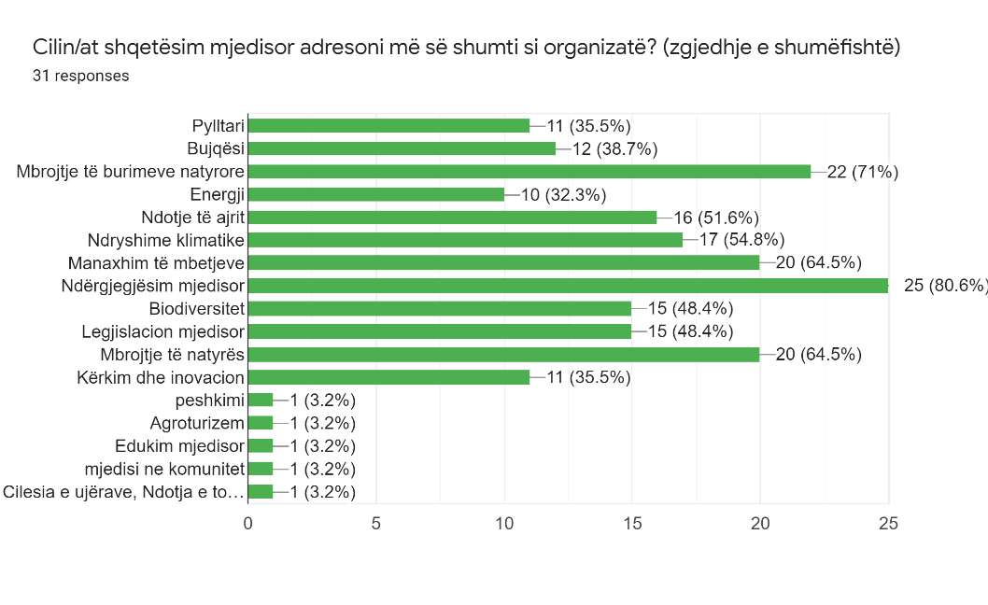**Figure 16. Environmental concerns mostly addressed from CSOs in the Central Region**

**Main cooperation with each other:**

*1)Activists*

*2)CSOs;*

*3) Local government;*

**Factors affecting women's participation in activities:**

*1) Education;*

*2) Local Mentalities;*

*3) Social aspects;*

*4) Environmental awareness can be simpler working with groups of women as they are the ones who mainly deal with household waste management;*

*5) Cultural traditions and family burdens;*

*6) Economic independence;*

*More than 50% of respondents answered that there are factors preventing woman and girls to participate in environment-topic activities.*

**Figure 17. Perception of CSOs regarding factors affecting women's participation in environmental activities in the Central Region**

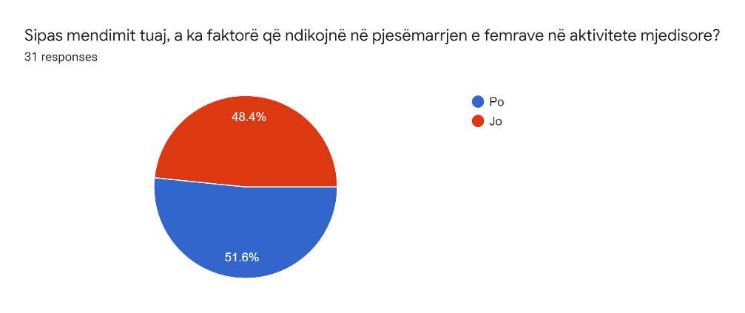

**In the framework of the questionnaire developed for CSOs, it turned out that almost 40% of them had no history of previous cooperation with CSOs related to Woman’s Empowerment actions.**

**Figure 18. Level of cooperation between CSOs and Women's Empowerment organizations in the Central Region**

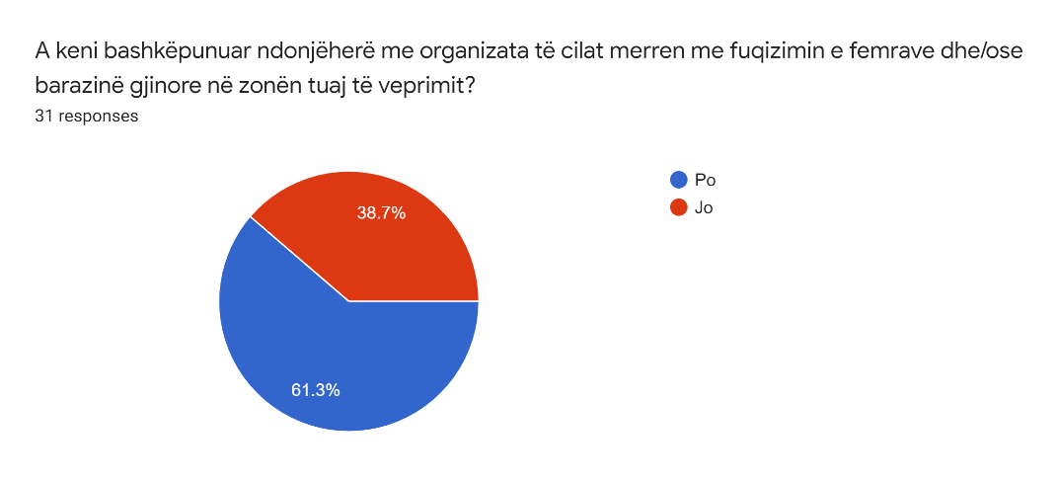

**Main fields of experience of CSOs:**

*1) Analysis of social services;*

*2) Strengthening the role of women in environmental decision-making.*

*3) Gender budgeting with international organizations;*

*4) Involvement of women and young girls in the voting process;*

*6) Professional training of local woman.*

*7) Analysis and awareness activity related to gender equality in the water sector, entrepreneurship, biodiversity, water supply and sewerage;*

**Environmental issues that generally affect the sustainability and quality of life in the community:**

* + 1. *Air pollution in urban areas;*
    2. *Urban solid waste management;*
    3. *Noises;*
    4. *Water pollution;*
    5. *Lack of respect and commitment to environmental issues;*
    6. *The economic development model does not include environmental issues and environmental integration;*
    7. *Illegality against natural resources (deforestation, deforestation, river pollution, dumping of waste along the road, etc.);*
    8. *Excessive urbanization in the city and lack of green spaces / Lack of sustainable planning / Lack of quality monitoring;*
    9. *Habitat reduction and biodiversity loss. Disruption of balances in ecosystems by changing physio-chemical components;*
    10. *Poor municipal services in the environment;*
    11. *Natural resource management;*

**Proposed ways to help on sustainability and quality of life in the community issues:**

* + 1. *Education / Awareness / Projects that address this problem. Strengthening organizations dealing with the environment;*
    2. *Improving the legal framework for the environment and strengthening law enforcement; Sustainable Management of Protected Areas; Strategic study and planning on adaptation to climate change; Monitoring, study and protection of endangered species;*
    3. *Continuous monitoring of air, water and noise pollution;*
    4. *Education and awareness of farmers and residents of the area on the damage caused by indiscriminate use of pesticides and increase market safety of these products.*
    5. *Ensuring integrated waste management and education of generations through educational and media programs. Waste classification at source;*
    6. *Educational and information media campaign with farmers and specialists of the sector as well as the increase of customs and tax control on the origin and quality of pesticides and fertilizers;*
    7. *Strengthen environmental CSOs to push concrete policies that improve the legal and regulatory framework but also their implementation, better institutional coordination accompanied by capacity building, Increasing the advocacy and monitoring power of the public and CSOs in general for promote the accountability of public instances;*
    8. *Real environmental studies, national strategies based on EU directives, law enforcement;*

**Acknowledged Environmental initiatives in the region:**

*1) Clean Air Campaign;*

*2) Albanian beekeeping;*

*3) Initiative for the protection of the Vjosa River;*

*4) Domestic violence;*

*5) Green lungs in our cities;*

**Requested support from Green-Al project:**

Thematic

* *Protection of natural resources;*
* *Impact on the community;*
* *Institutional coordination;*
* *Waste management, protection and improvement of forests;*
* *Natural resource management;*
* *Environmental risk assessment;*

Administrative

* *Fund raising;*
* *Project proposal writing & planning;*
* *Capacity Building, Fundraising, Networking;*
* *Advocacy;*

**Type of grants requested in case of application:**

1. *Initiative grants.*
2. *Partnership Grants*
3. *Networking Grants and Policy Impact*
4. *Communication and Mobilization Grants*

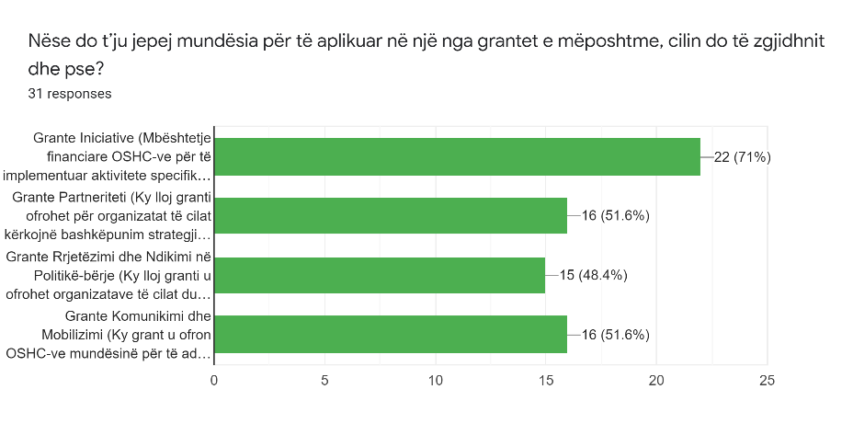**Figure 19. Expressed interest of CSOs per type of grant in the Central Region**

1. **SYNTHETIZED CONCLUSIONS**

All key findings per each region summarized on a national level indicate that the project proposal addressed most of the needs and it is flexible enough to adapt both thematically and technically to the needs and issues confirmed by local ECSOs and Activist. Therefore, we must conclude that the incubation process and the grant modules were seen as a good opportunity by CSOs to position themselves adequately.

Thematic support - from the needs assessment the priority areas coming from NGOs are the following. Which correspond to the existing expertise of Green-Al consortium. Therefore, these areas can be supported and mentored by the project team.

* Flora and the fauna are threatened by the misuse and the poor management of these resources with a great environmental, economic, and social value.
* Degradation has a number of consequences that limit both existing and future opportunities for human use of the area, such as: Erosion and sinking of low-lying areas by rising sea levels and rising storm frequencies, leading to loss of space;
* Change of hydrological regime, leading to loss of freshwater for agriculture, other industries and for domestic use;
* Loss of wetland area, leading to reduced opportunity for protection from rising sea levels, loss of attractive values ​​of ecosystems and their services; Habitat and biodiversity change leading to loss of resources and environmental renewal.
* Erosion, overuse of groundwater, degradation of natural protected areas and impoverishment of biodiversity.
* Urban Environment Health (Waste Management, Noise and air pollution, Waste Water Treatment)
* Climate Change, Resilience, Disaster Risk Reduction
* Circular Economy

**Gender - From the survey gender did not come high in priorities, apart of the northern region where we intend to channel more efforts and cross-cutting activities.**

* Most of the women in the CSOs hold support staff positions.
* Unemployment or low income.
* Women express interest in being involved in the activities of associations and would like to be informed of the activities, also becoming members.
* Lower education levels than man.
* Lower access to financial resources than man.
* Vulnerability is higher on woman on psychological and mental health issues.
* Need to integrated gender in crosscutting environmental issues

**Finally, the basic administrative needs from CSOs**

* Project cycle management
* Participatory approaches and community mobilization
* Stakeholders’ analysis and policy dialogue strategies networking and communication
* Advocacy (problem analysis, solution findings and knowledge/evidence-based data utilization for policy orientation)

1. **RECOMANDATIONS**

Given the overall results do not indicate a major need for a substantial intervention on the project log-frame and its main activities. We conclude that the overall project approach is appropriate. However slight modifications are needed to increase project responsiveness. We propose the following indicators, that might pose also budget revisions, should orient our discussion on concluding with the inception phase:

1. **Incubation**

Foreseen as a direct support by the consortium to CSOs, consisting on a total of 40 trainings, coaching and mentoring sessions. Can now be determined further on to a equal distribution per each region of:

* 8 sessions on administrative and project cycle management
* 12 sessions on gender
* 20 sessions on thematical capacity building

To be discussed here is the need for a Gender Expert at a project level that would support not only the incubation process but also ensure that the project target indicators referring to Output 1.3 of the revised log-frame are met.

1. **Grant Modules**

Most of the interviewed CSOs and Activist are interested on Initiative and Partnership Grants due to their interest to work closely with their communities and territory. In this we also see the potential that the following grant module of Networking can benefit by obtaining grass-root input and voice up for mainstreaming and solution.

Here we were required to issue small grants also for individuals, activists or community representatives supporting their cause. Aside of opportunities and potential we see in this poses the risk of increasing the consortium workload due to the fact that financially these individuals will have to operate through us. Nevertheless this, among others is one of the discussions points we will exhaust during the consultation with the program officer and other donor representatives.

1. **Project Needs**

During the inception phase our work on coordination, reporting, internal training, workshops attendance etc, resulted as very demanding whilst we had the opportunity to increase our presence locally (due to the ease of pandemic restrictions) but timewise it was quite impossible.

Another important part, identification of local activist, initiatives, experts and entities to collaborate with can only be achieved through in-person meeting and site-visits.

The field activities in the region request a constant presence on field to keep mobilization and active participation during all process and commitment in outreaching those groups less visible but crucial for the activity implementation also in more remote areas. Therefore, we propose to address this issue by increasing at least with 25% our dedicated travel budget-lines,

Finally, we would also see feasible to increase our local presence not just in frequency but also in number of supporting and thematic staff. Without detailing or appointing workloads or extra-positions at the moment, we propose to discuss this matter further on with the program officer and other donor representatives.

# ANNEX 1: QUESTIONNAIRE FOR ENVIRONMENTAL CIVIL SOCIETY ORGANIZATIONS

This questionnaire is conducted within the project "Empower Grass-Root CSOs for Improved Innovative Environmental Protection in Albania" (Green-AL). The project is funded by the Swedish International Development Cooperation Agency (SIDA), managed by Co-PLAN, Institute for Habitat Development as the lead partner and CISP, VIS and COSV as support partners.

The questionnaire is conducted for the Environmental Civil Society Organizations working in the municipalities included in the territories of Tirana, Durrës, Fier and Elbasan Qark. The aim of the questionnaire is to understand the current status and to address further needs of CSOs within the environmental realm.

Completed questionnaires and your answers will be used only for statistical presentation of research results on this issue. The questionnaire does not represent an exam of knowledge, there are no correct or incorrect answers, and the subject of interest is only your opinion on the questions asked. Please take 10 minutes of your precious time and conscientiously fill out the survey questionnaire.

Thank you in advance!

1. *Name of organization:

*E-mail:

Contact number:

Address:

1. How long has your ECSO been active?
2. How many staff members does your organization have?

3-5

6-10

10-20

over 20

1. How many women and how many men work in your organization?   
   *Female……. Male………*
2. What is the role of women in your organization? (multiple choice)

* Leading position
* Expert
* Support staff
* Volunteer
* Other: ___________________

1. Which type of environmental issues do you address the most? (multiple choice)

* Forestry
* Agriculture
* Water resources protection
* Energy
* Air pollution
* Climate change
* Waste management
* Awareness
* Biodiversity
* Environmental legislation
* Nature protection
* Research and innovation
* Other: ___________________

1. What are the geographical areas of your activities? (*Please specify the municipality and/or the community*)
2. Do you work together with other local public and/or private actors?

* No
* Yes

If yes please specify which one:

* *CSO*
* *Local government,*
* *Educational institutions*
* *Academia*
* *Small and medium enterprises*
* *National institutions*
* *Other (please specify): _______________________*

1. Have you ever cooperated with organizations focusing on women empowerment and/or gender equality in your area? If yes, briefly say something about the experience.

________________________________________________________________________________________________________________________________________________________________________________________________________________________

1. In your opinion, is the number of women engaged and participating in the environmental sector significantly lower compared to the number of men?

* True
* False

1. Which are your main financial resources?

* Membership
* Grants from International Donors
* Sub grants from CSO
* Local Public funds
* National Public Funds
* Social Enterprise
* Other (Please specify): ___________________________

1. In the last 5 years, how many projects have you implemented (*both as lead applicant and as partner*)?

Please, list the projects from oldest to newest:

1. ____________________________________________
2. ____________________________________________
3. ____________________________________________
4. ____________________________________________
5. ____________________________________________
6. From 1 (*minimum*) to 5 (*maximum*), how strong do you consider your ECSO in the following areas?

Fundraising 1 2 3 4 5

Project writing and application 1 2 3 4 5

Project Cycle Management 1 2 3 4 5

Financial Management 1 2 3 4 5

Financial reporting 1 2 3 4 5

Advocacy and lobbying 1 2 3 4 5

Gender equality 1 2 3 4 5

Networking 1 2 3 4 5

Environmental awareness 1 2 3 4 5

Innovative solutions 1 2 3 4 5

Monitoring and evaluation 1 2 3 4 5

Communication 1 2 3 4 5

Policy cycle & influencing 1 2 3 4 5

1. Are you aware of any successful initiative in your territory/community addressing an environmental issue, sustainable development or decision-making influence?

* Yes
* No

If yes, please describe the initiatives of organizations/entities promoting it/them (*if governmental, non-governmental, CSOs, private actors, women association other, etc*.)

1. “Women are more affected than men by the negative social consequences of environmental issues in the local communities.”

* True
* False
* Equally affected

1. In your opinion, are there any factors that influence, or may have a disproportionate impact, in women's participation in environmental activities?

* Yes
* No

If yes, please specify maximum 3 factors:

3. Has your organization or its members attended any training on environmental issues and/or on Project cycle management?

* Yes
* No

If yes, please describe the topic and the provider: ________________________________________________

1. If you could benefit of training and info sessions, which topic would you like to be trained on?

*Please indicate at least 3 main topics:*

1. What are some of the environmental issues that impact the overall sustainability and quality of life in your community and/or that you want to/can tackle?
2. ______________________
3. ______________________
4. ______________________
5. ______________________
6. ______________________
7. Shortly, how can these environmental issues be solved?

________________________________________________________________________________________________________________________________________________________________________________________________________________________________________________________________________________________________________________________________________________________________________

1. Has your ECSO ever been invited/participated and given contribution to consultations organized by local public institutions to contribute to the strategic planning of the governance (*action plans, management plans, waste management plan etc*.)?

* Yes
* No

If yes, please specify:

________________________________________________________________________________________________________________________________________________________________________________________________________________________________________________________________________________________________

1. If given the possibility of applying for one of the following grants which one are you more likely to apply to and why?

* **Initiative grants** *(working with local communities in implementing specific environmental issues)*
* **Partnership grants** *(working with local government units, private sector and specialized environmental entities on a specific environmental topic)*
* **Networking** *(collaborating with other CSOs of other areas of the country to implement activities regarding shared environmental problems)*
* **Advocacy and Policy Making** *(addressing environmental concerns at a local level through communication and advocacy campaigns)*

Specify why: __________________________________________________________________________________________________________________________________________________________________________________________________________________________________________________________________________________________

# ANNEX 2: ENVIRONMENTAL ACTIVISTS, EDUCATION INSTITUTIONS, ACADEMIA, LOCAL PRIVATE BUSINESSES

This questionnaire is conducted within the project "Empower Grass-Root CSOs for Improved Innovative Environmental Protection in Albania" (Green-AL). The project is funded by the Swedish International Development Cooperation Agency (SIDA), managed by Co-PLAN, Institute for Habitat Development and partners CISP, VIS and COSV.

The questionnaire is conducted for the Environmental Activists working in the municipalities included in the territories of Tirana, Durrës, Fier and Elbasan Qark. The aim of the questionnaire is to understand the current status and to address further needs of activists, education institutions, academia and local private businesses within the environmental realm.

Completed questionnaires and your answers will be used only for statistical presentation of research results on this issue. The questionnaire does not represent an exam of knowledge, there are no correct or incorrect answers, and the subject of interest is only your opinion on the questions asked. Please take 10 minutes of your precious time and conscientiously fill out the survey questionnaire.

Thank you in advance!

1. *Name & Surname:

*E-mail:

Contact number:

1. Age:
2. Sex:

* Male
* Female

1. Level of education:

* Elementary education
* High school graduate
* Bachelor’s degree
* Master’s degree
* Professional degree
* Doctorate degree

1. Location of work/action: (*specify Municipality and/or the community*)
2. Characteristics of your focus area:

* Urban areas
* Suburban areas
* Rural areas

1. Do you act individually or in group?

* Individually
* In a group

1. Is your group formally recognized in the community or legally established by the rules of the Republic of Albania?

* Yes
* No

1. Is your group composed by?

* Only man,
* Only women
* Mixed

1. If the last option, can you please provide information on the number of women and men in your group/association?

Male: ________

Female: _________

1. What is the role of women in your organization? (multiple choice)

* Leading position
* Expert
* Support staff
* Volunteer
* Other: ___________________

1. “Women are affected disproportionately by the negative social consequences of environmental issues.”

* True
* False
* Equally affected

1. When and why did you start being an environmental activist?

________________________________________________________________________________________________________________________________________________________________________________________________________________________

1. In your experience, which is the most pressing environmental issue affecting your area of intervention - actual or potential?

* Air emissions,
* Water and/or waste,
* Resource depletion,
* Noise pollution
* Other: _______________________

1. Which type of environmental concerns do you address the most?

* Forestry
* Agriculture
* Water resources protection
* Energy
* Air pollution
* Climate change
* Waste management
* All of them
* Other: _________________

1. In what kind of activities have you participated regarding environmental protection in different areas in Albania?

________________________________________________________________________________________________________________________________________________

1. What do you consider a personal achievement of yours being an activist/education institution/academia/private business in the environmental realm?

________________________________________________________________________________________________________________________________________________________________________________________________________________________

1. Have you had possibility to attend training/info sessions on environmental issues?

* Yes

If yes, please specify what kind of training: ______________________

* No

If no, please specify why: _____________________________

1. In your opinion, which are the main sectors where women are directly involved in the process of natural resources management?

* Agriculture
* Forestry
* Biodiversity conservation
* Local products valorization other (*please specify*) ____________________________
* Eco-friendly entrepreneurship

1. In your opinion, which are the factors that influence or may have an impact in women's participation in environmental activities?

________________________________________________________________________________________________________________________________________________________________________________________________________________________

1. Have you ever reported to the public institution an environmental issue? If yes, what type of issue and what kind of reaction/feedback did you receive?

________________________________________________________________________________________________________________________________________________________________________________________________________________________

1. In your opinion, how important is each of the following to promote environmental responsibility?

Education  Not important  Important  Very important

Media/Social media  Not important  Important  Very important

Campaigns  Not important  Important  Very important

Imposing fines  Not important  Important  Very important

_____________  Not important  Important  Very important

1. Have you participated in exchange experiences with other communities of activists in the country or the region?

* Yes
* No

If yes, please specify:

________________________________________________________________________________________________________________________________________________________________________________________________________________________________________________________________________________________________________________________________________________________________________

1. In your opinion do local and national policies encourage responsible behavior in

terms of environmental sustainability?

* Yes
* No

If no, please specify how it can be encouraged:

_________________________________________________________________________________________________________________________________________________________________________________________________________________________________________